**DBMS Project**

**ER- Diagram**

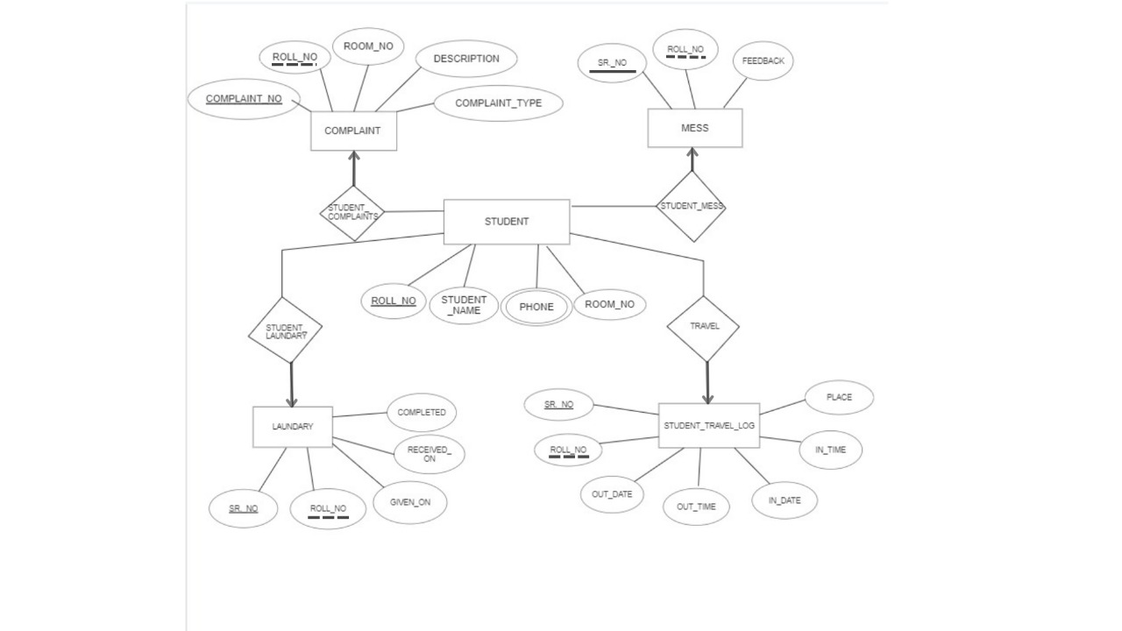

**ER TO TABLE:**

|  |
| --- |
| **STUDENT** |
| ROLL_NO  STUDENT_NAME  PHONE  ROOM_NO |

|  |
| --- |
| **COMPLAINT** |
| COMPLAINT_NO  ROLL_NO  ROOM_NO  DESCRIPTION  COMPLAINT_TYPE |

|  |
| --- |
| **LAUNDARY** |
| SR_NO  ROLL_NO  GIVEN_NO  RECEIVED_ON  COMPLETED |

|  |
| --- |
| **MESS** |
| SR_NO  ROLL_NO  FEEDBACK |

AIM:

Our project is based on Hostel Management. In our project, we have tried to modernize the conventional file-based registries still being used.

Description:

In this project, we have focused on 3 main departments namely Complaint Department, Mess Department, and the laundry department. In this project, we have used technologies like SQL and PL/SQL for various operations that can be performed in our database.

Normalization Process:

1NF- First Normal Form

If a relation contains a composite or multi-valued attribute, it violates the first normal form, or the relationship is in the first normal form if it does not contain any composite or multi-valued attribute. A relation is in its first normal form if every attribute in that relation is singled valued attribute.

A table is in 1 NF iff:

1. There are only Single Valued Attributes.
2. Attribute Domain does not change.
3. There is a unique name for every Attribute/Column.
4. The order in which data is stored does not matter.

Student Table

Roll No -- Roll No column satisfies all the above conditions.

Student_Name – Student_Name column satisfies all the above conditions.

Room_No – Room_no column satisfies all the above conditions.

Phone No – Here phone number is a multivalued column. To get our table in a 1NF form we need to make it a single-valued column. For that, we decompose the phone numbers into 2 different columns namely Phone_No1 and Phone_No2.

|  |
| --- |
| **STUDENT** |

|  |  |  |  |
| --- | --- | --- | --- |
| ROLL_NO | STUDENT_NAME | PHONE | ROOM_NO |

|  |  |  |  |  |
| --- | --- | --- | --- | --- |
| ROLL_NO | STUDENT_NAME | PHONE_NO_1 | PHONE_NO_2 | ROOM_NO |

Complaint Table

All the attributes satisfy the above 4 conditions. Our Complaint table is already in First Normal Form.

|  |
| --- |
| **COMPLAINT** |

|  |  |  |  |  |
| --- | --- | --- | --- | --- |
| COMPLAINT_NO | ROLL_NO | ROOM_NO | DESCRIPTION | COMPLAINT_TYPE |

Mess Table

All the attributes satisfy the above 4 conditions. Our Complaint table is already in First Normal Form.

|  |
| --- |
| **MESS** |

|  |  |  |
| --- | --- | --- |
| SR_NO | ROLL_NO | FEEDBACK |

Laundry Table

All the attributes satisfy the above 4 conditions. Our Complaint table is already in First Normal Form.

|  |
| --- |
| **LAUNDARY** |

|  |  |  |  |  |
| --- | --- | --- | --- | --- |
| SR_NO | ROLL_NO | GIVEN_ON | RECEIVED_ON | COMPLETED |

Now we have our database schema normalized to the First Normal Form.

2NF- Second Normal Form

To be in the second normal form, a relation must be in the first normal form and the relation must not contain any partial dependency. A relation is in 2NF if it has No Partial Dependency, i.e., no non-prime attribute (attributes that are not part of any candidate key) is dependent on any proper subset of any candidate key of the table.

Student Table

|  |
| --- |
| **STUDENT** |

|  |  |
| --- | --- |
| ROLL_NO | STUDENT_NAME |

|  |  |  |
| --- | --- | --- |
| ROLL_NO | PHONE_NO_1 | PHONE_NO_2 |

|  |  |
| --- | --- |
| ROLL_NO | ROOM_NO |

Complaint Table

|  |
| --- |
| **COMPLAINT** |

|  |  |
| --- | --- |
| COMPLAINT_NO | ROLL_NO |

|  |  |  |
| --- | --- | --- |
| COMPLAINT_NO | DESCRIPTION | COMPLAINT_TYPE |

Mess Table

|  |
| --- |
| **MESS** |

|  |  |
| --- | --- |
| SR_NO | ROLL_NO |

|  |  |
| --- | --- |
| SR_NO | FEEDBACK |

Laundry Table

|  |
| --- |
| **LAUNDARY** |

|  |  |
| --- | --- |
| SR_NO | ROLL_NO |

|  |  |  |  |
| --- | --- | --- | --- |
| SR_NO | GIVEN_ON | RECEIVED_ON | COMPLETED |

3NF- Third Normal Form

*A relation that is in First and Second Normal Form and in which no non-primary-key attribute is transitively dependent on the primary key, then it is in Third Normal Form (3NF).* If A->B and B->C are two FDs then A->C is called transitive dependency.

Student Table

|  |  |
| --- | --- |
| ROLL_NO | STUDENT_NAME |

|  |  |  |
| --- | --- | --- |
| ROLL_NO | PHONE_NO_1 | PHONE_NO_2 |

|  |  |
| --- | --- |
| ROLL_NO | ROOM_NO |

Complaint Table

|  |  |
| --- | --- |
| COMPLAINT_NO | ROLL_NO |

|  |  |  |
| --- | --- | --- |
| COMPLAINT_NO | DESCRIPTION | COMPLAINT_TYPE |

Mess Table

|  |  |
| --- | --- |
| SR_NO | ROLL_NO |

|  |  |
| --- | --- |
| SR_NO | FEEDBACK |

Laundry Table

|  |  |
| --- | --- |
| SR_NO | ROLL_NO |

|  |  |  |  |
| --- | --- | --- | --- |
| SR_NO | GIVEN_ON | RECEIVED_ON | COMPLETED |

BCNF

BCNF is the advanced version of 3NF. It is stricter than 3NF. A table is in BCNF if every functional dependency X → Y, X is the super key of the table. For BCNF, the table should be in 3NF, and for every FD, LHS is super key.

Student Table

|  |  |
| --- | --- |
| ROLL_NO | STUDENT_NAME |

|  |  |  |
| --- | --- | --- |
| ROLL_NO | PHONE_NO_1 | PHONE_NO_2 |

|  |  |
| --- | --- |
| ROLL_NO | ROOM_NO |

Complaint Table

|  |  |
| --- | --- |
| COMPLAINT_NO | ROLL_NO |

|  |  |  |
| --- | --- | --- |
| COMPLAINT_NO | DESCRIPTION | COMPLAINT_TYPE |

Mess Table

|  |  |
| --- | --- |
| SR_NO | ROLL_NO |

|  |  |
| --- | --- |
| SR_NO | FEEDBACK |

Laundry Table

|  |  |
| --- | --- |
| SR_NO | ROLL_NO |

|  |  |  |  |
| --- | --- | --- | --- |
| SR_NO | GIVEN_ON | RECEIVED_ON | COMPLETED |

4NF- Fourth Normal Form

The fourth normal form (4NF) is a level of database normalization where there are no non-trivial multivalued dependencies other than a candidate key. It builds on the first three normal forms (1NF, 2NF, and 3NF) and the Boyce-Codd Normal Form (BCNF). It states that, in addition to a database meeting the requirements of BCNF, it must not contain more than one multivalued dependency.

Properties – A relation R is in 4NF if and only if the following conditions are satisfied: 

1. It should be in the Boyce-Codd Normal Form (BCNF).
2. the table should not have any Multi-valued Dependency.

Student Table

|  |  |
| --- | --- |
| ROLL_NO | STUDENT_NAME |

|  |  |
| --- | --- |
| ROLL_NO | PHONE_NO_1 |

|  |  |
| --- | --- |
| ROLL_NO | PHONE_NO_2 |

|  |  |
| --- | --- |
| ROLL_NO | ROOM_NO |

Complaint Table

|  |  |
| --- | --- |
| COMPLAINT_NO | ROLL_NO |

|  |  |  |
| --- | --- | --- |
| COMPLAINT_NO | DESCRIPTION | COMPLAINT_TYPE |

Mess Table

|  |  |
| --- | --- |
| SR_NO | ROLL_NO |

|  |  |
| --- | --- |
| SR_NO | FEEDBACK |

Laundry Table

|  |  |
| --- | --- |
| SR_NO | ROLL_NO |

|  |  |  |  |
| --- | --- | --- | --- |
| SR_NO | GIVEN_ON | RECEIVED_ON | COMPLETED |

5NF- Fifth Normal Form

A relation R is in 5NF if and only if every join dependency in R is implied by the candidate keys of R. A relation decomposed into two relations must have loss-less join Property, which ensures that no spurious or extra tuples are generated when relations are reunited through a natural join.

Properties – A relation R is in 5NF if and only if it satisfies the following conditions: 

1. R should be already in 4NF.
2. It cannot be further no loss decomposed (join dependency)

Student Table

|  |  |
| --- | --- |
| ROLL_NO | STUDENT_NAME |

|  |  |
| --- | --- |
| ROLL_NO | PHONE_NO_1 |

|  |  |
| --- | --- |
| ROLL_NO | PHONE_NO_2 |

|  |  |
| --- | --- |
| ROLL_NO | ROOM_NO |

Complaint Table

|  |  |
| --- | --- |
| COMPLAINT_NO | ROLL_NO |

|  |  |  |
| --- | --- | --- |
| COMPLAINT_NO | DESCRIPTION | COMPLAINT_TYPE |

Mess Table

|  |  |
| --- | --- |
| SR_NO | ROLL_NO |

|  |  |
| --- | --- |
| SR_NO | FEEDBACK |

Laundry Table

|  |  |
| --- | --- |
| SR_NO | ROLL_NO |

|  |  |  |  |
| --- | --- | --- | --- |
| SR_NO | GIVEN_ON | RECEIVED_ON | COMPLETED |

**Create table**

create table student_n(

roll_no number(20) primary key ,

student_name varchar2(20)

);

create table student_ph1(

roll_no number(20) primary key references student_n(roll_no),

student_phone1 number(10) );

create table student_ph2(

roll_no number(20) primary key references student_n(roll_no),

student_phone2 number(10) );

create table student_r(

roll_no number(20) primary key references student_n(roll_no),

student_room_no number(5));

create table complaint_table(

complaint_no number(10) primary key,

roll_no number(20) references student_n(roll_no));

create table complaint_info(

complaint_no number(10) primary key references complaint_table(complaint_no),

description varchar2(100),

complaint_type varchar2(20));

create table mess_table(

sr_no number(10) primary key,

roll_no number(20) references student_n(roll_no));

create table mess_info(

sr_no number(10) primary key references mess_table(sr_no),

feedback varchar2(100));

create table laundry_table(

sr_no number(10) primary key,

roll_no number(20) references student_n(roll_no));

create table laundry_info(

sr_no number(10) primary key references laundry_table(sr_no),

given_on date,

recieved_on date ,

completed varchar2(1));

PL/SQL

------------------------------------------------------------------------------

CREATE OR REPLACE PROCEDURE insert_data (

roll student_n.roll_no%TYPE,

name student_n.student_name%TYPE,

phone1 student_ph1.student_phone1%TYPE,

phone2 student_ph2.student_phone1%TYPE,

room student_r.student_room_no%TYPE)

IS

BEGIN

INSERT INTO student_n (roll_no, student_name)

VALUES (roll,name);

INSERT INTO student_ph1 (roll_no, student_phone1)

VALUES (roll,phone1);

INSERT INTO student_ph2 (roll_no, student_phone1)

VALUES (roll,phone2);

INSERT INTO student_r(roll_no, student_room_no)

VALUES (roll,room);

COMMIT;

END;

/

begin

insert_data(102,'ramu',9863354,47534724,13);

end;

/

select * from student_n;

select * from student_ph1;

select * from student_ph2;

select * from student_r;

create or replace procedure add_complaint(

c_no complaint_table.complaint_no%type,

roll complaint_table.roll_no%type,

disc complaint_info.description%type,

c_type complaint_info.complaint_type%type

)

is

begin

insert into complaint_table(complaint_no,roll_no)

values(c_no,roll);

insert into complaint_info(complaint_no,description,complaint_type)

values(c_no,disc,c_type);

commit;

end;

/

/*

begin

add_complaint(122,102,'good service','mess');

end;*/

/

select * from complaint_table;

select * from complaint_info;

/*

create or replace procedure add_mess(

sno mess_table.sr_no%type,

roll mess_table.roll_no%type,

feed mess_info.feedback%type

)

is

begin

insert into mess_table(sr_no,roll_no)

values(sno,roll);

insert into mess_info(sr_no,feedback)

values(sno,feed);

commit;

end;

/

begin

add_mess(1,102,'v.good');

end;

/

*/

/*

select * from mess_table;

select * from mess_info;

*/

/*

create or replace procedure add_mess(

sno mess_table.sr_no%type,

roll mess_table.roll_no%type,

feed mess_info.feedback%type

)

is

begin

insert into mess_table(sr_no,roll_no)

values(sno,roll);

insert into mess_info(sr_no,feedback)

values(sno,feed);

commit;

end;

/

*/

declare

sno mess_table.sr_no%type;

begin

select max(sr_no)into sno from mess_table;

sno:=sno+1;

add_mess(sno,102,'v.v.v.good');

end;

/

select * from mess_table;

select * from mess_info;

create or replace procedure add_laundry(

sno laundry_table.sr_no%type,

roll laundry_table.roll_no%type,

g_date laundry_info.given_on%type,

r_date laundry_info.recieved_on%type,

comp laundry_info.completed%type

)

is

begin

insert into laundry_table(sr_no,roll_no)

values(sno,roll);

insert into laundry_info(sr_no,given_on,recieved_on,completed)

values(sno,g_date,r_date,comp);

commit;

end;

/

declare

sno laundry_table.sr_no%type;

begin

select max(sr_no) into sno from laundry_table;

sno:=sno+1;

add_laundry(sno,102,to_date('21-07-2002','dd-mm-yyyy'),to_date('22-07-2022','dd-mm-yyyy'),'y');

end;

/

select * from laundry_table;

select * from laundry_info;